Grant Proposal For
Healing from the
Heart
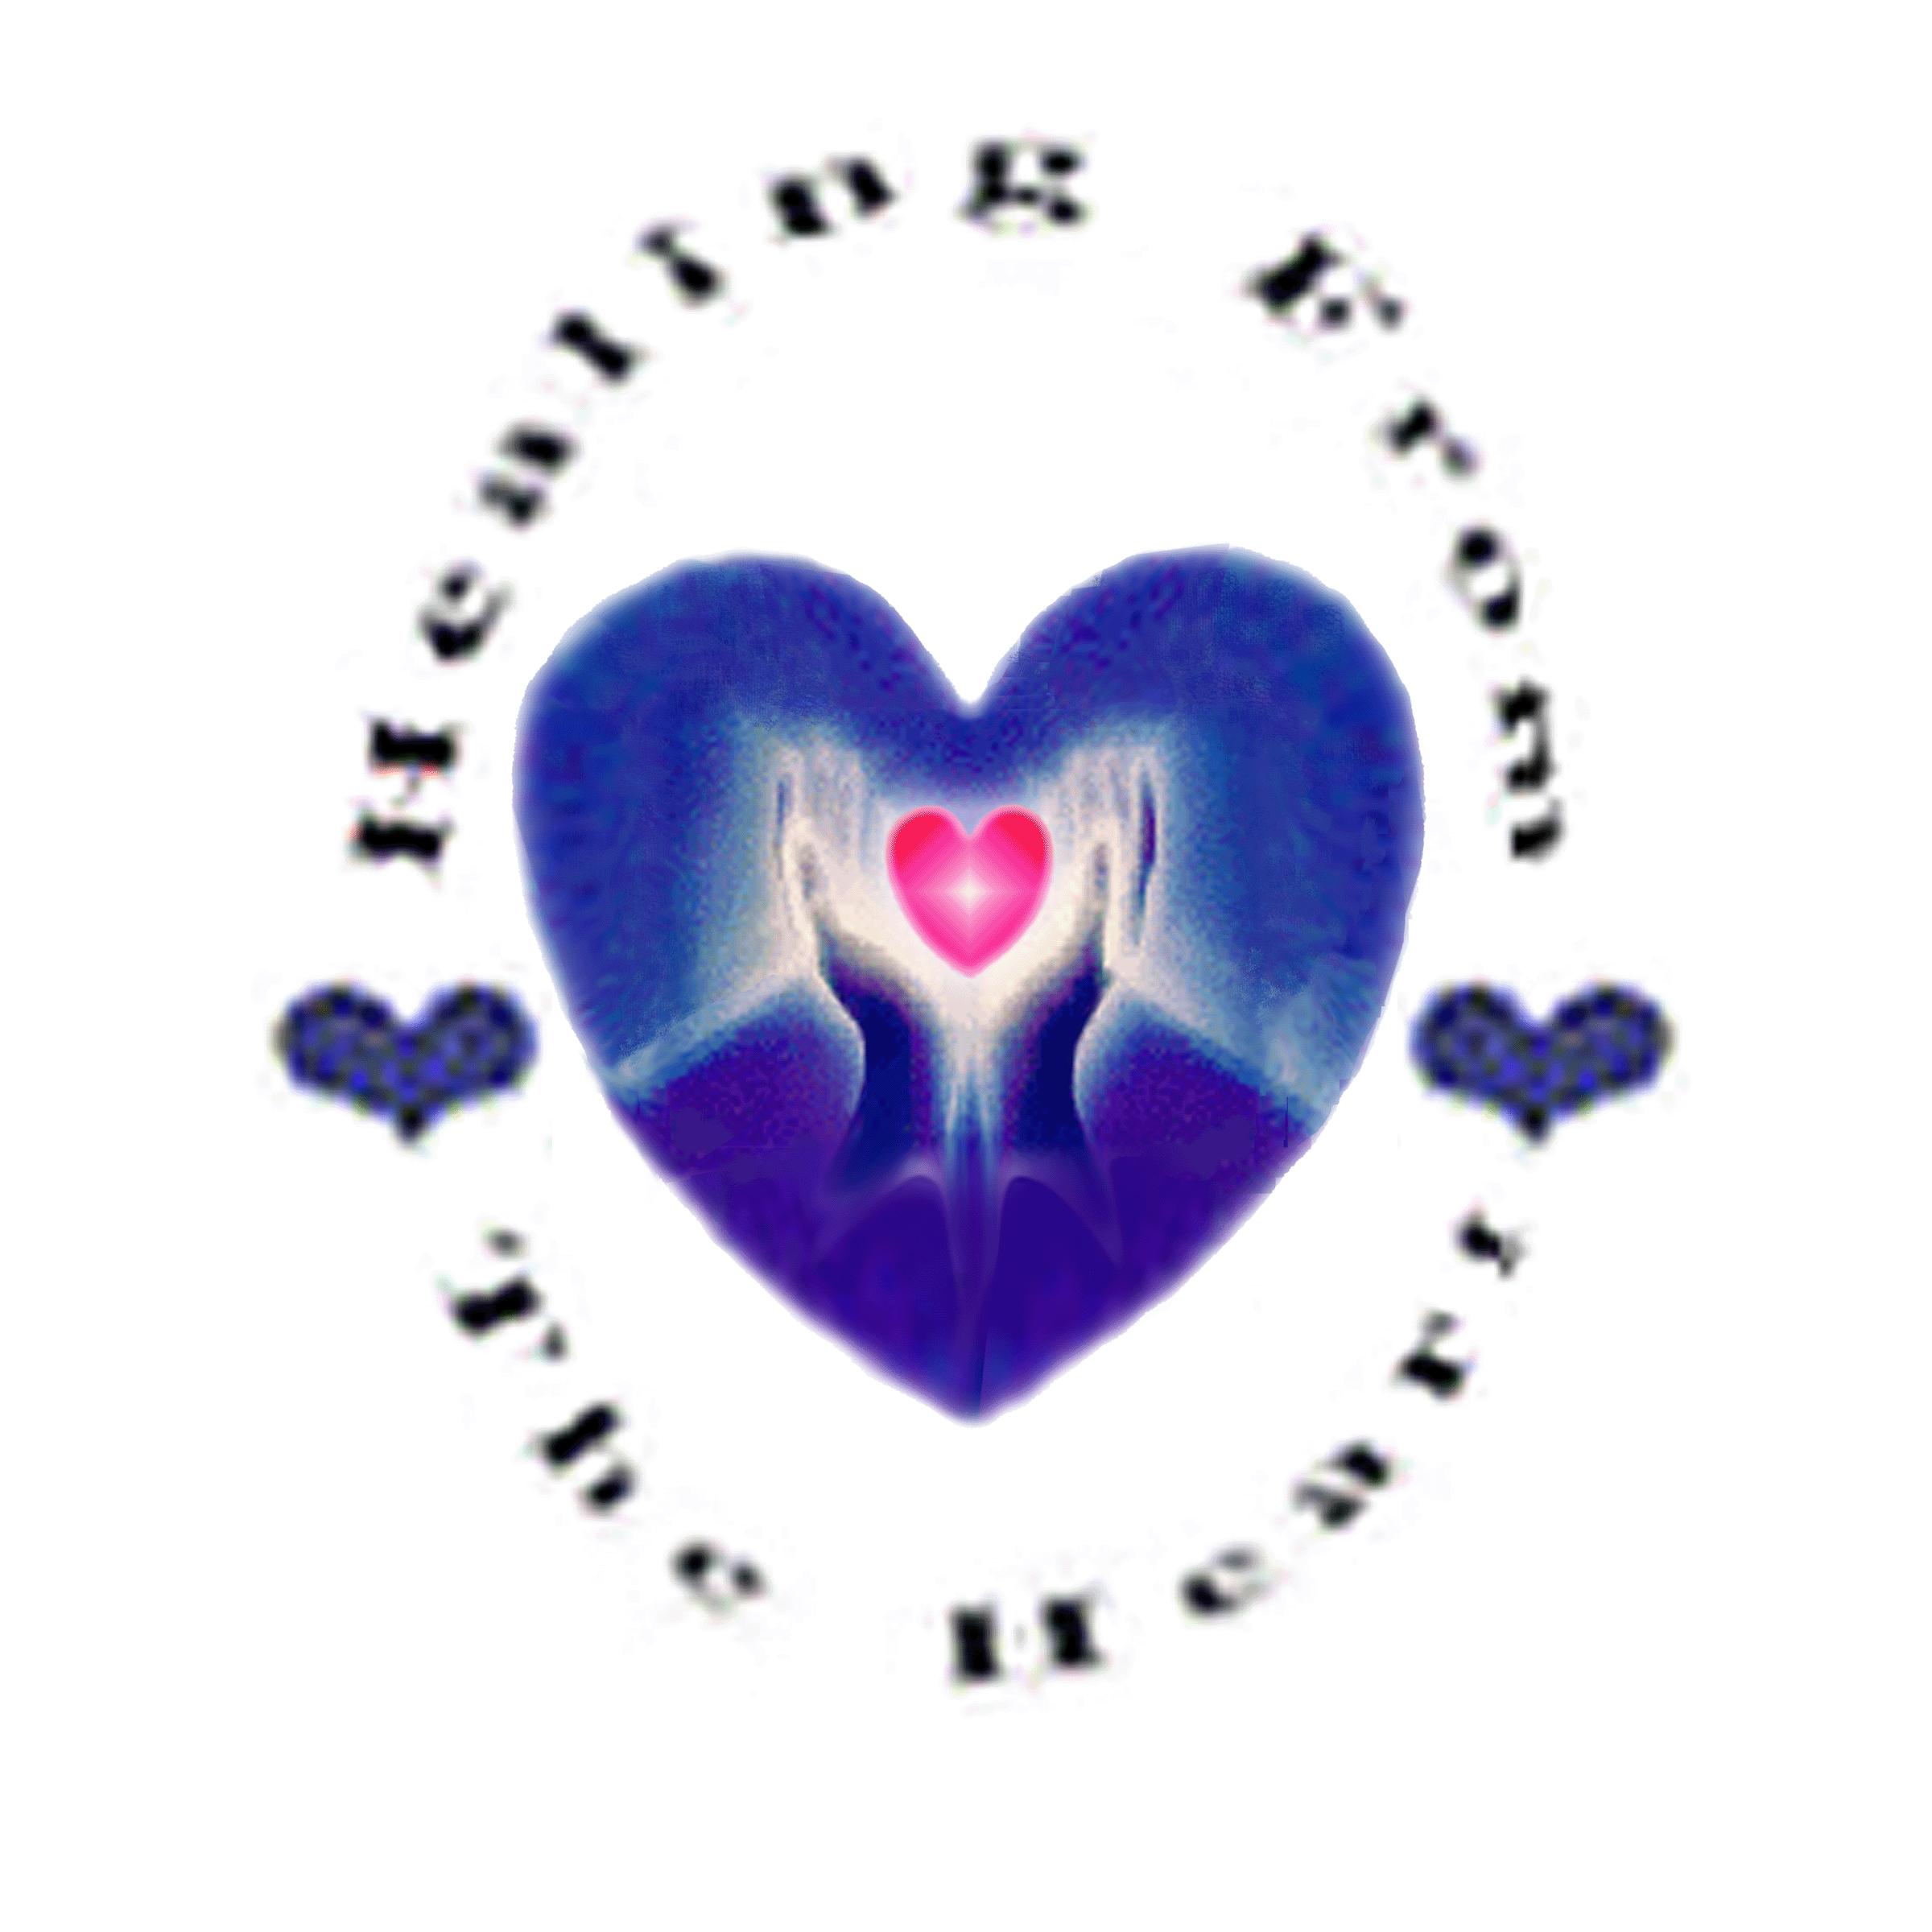

Prepared by:
Becky Lee Osterback, BSN
941 S.E Bidwell
Portland, OR 97202
And
W. 316 Boone, Suite 257
Spokane, WA 99201

Phone: (509) 344-3278
Fax: (509) 277-7777
Email: BeckyLee@HWWise.com
Web Site: www.HWWise.com

Table of Contents

Executive Summary 2
1. Legal Business Description 2
2. Mission Statement 2
3. Services Offered 2
4. Pricing and Profitability 2
5. Goals and Objectives 3
6. Overview of Market 3
7. Industry/Competition Analysis 3

Facilities and Operations
1. Location 4
2. Physical Facility 4
3. Capital Equipment 5
4. Availability of Labor 5

Market Analysis
1. Marketing and Sales Strategy 6
2. Management & Ownership 6
3. Personal Experience 7
4. Outside support Team 7
5. Earnings and Projected Success 7

Marketing and Sales Strategy
1. What is Healing Touch? 8
2. Description of Services 9 -10
3. Industry Trends 10
4. Foundations of Holistic Health 11-14
5. Healing Touch and the AMA 14
6. Competition /Primary Target Market Location 14- 16
7. Maps 17
8. Facilities & Operations 18
9. Sources of Supply 19
10. Objectives 20
11. Current Marketing Situation 21
12. Positioning Statement 21
13. Pricing strategy 21
14. Marketing Communications 22

Management
1. Plan Organization & implementation 23
2. Organizations Map 23
3. Statement of Purpose 23
4. Corporate Values 24

Financial
1. Pro Forma Statement of Cash Flows 25
2. Break Even Analysis 26
3. Income, Expense, Profit Breakdown 27
4. Dept to Equity Ratio 28
5. Sources and Uses of Cash 29

EXECUTIVE SUMMARY

Healing from the Heart is an existing alternative health and wellness service provider located in Spokane, Washington. The Organization, headed by Becky Lee Osterback who was a registered nurse in critical care for 24 years, provides personalized wellness training, healing therapy, fitness equipment supply, and a referral network to address health issues that are not effectively resolved by conventional health care providers.

The Organization is seeking funding of $4,825,000 to secure, purchase and maintain an established facility and to provide general working capital to facilitate the business’ expansion to include machines such as the Evolution Vibration Therapy machine, AquaMed hydrotherapy bed, Pharmanex BioPhotonic Scanner, Quantum Biofeedback, and Galvanic Spa System throughout expansion locations.

The Organization is in the process of developing Kiosks that measure a person’s health by using the scanner mentioned above, body mass index (BMI), blood pressure, pulse, and bone density which will then give a score of overall health. Our goal for these Kiosks is to automate them to be paid for by a credit card swipe that will activate a touch screen. There are more details about the Kiosks in the body of this Grant Proposal.

Our plan includes developing and maintaining a Healing Touch Therapy School to train Practitioners in this type of therapy. The cost of running this school will come from the funding stated above.

The Organization offers Healing Touch as a core service. Healing Touch is an energy-based treatment involving a group of non-invasive touch techniques that utilize the hands to clear, energize, and balance the human and environmental energy fields.

The primary target market for Healing from the Heart consists of adults seeking alternative medical treatment in the greater Spokane/Coeur d’Alene area.

The U.S. Centers for Disease Control and Prevention reports the key factors influencing an individual's state of health have not changed significantly over the past 20 years. Quality of medical care is only 10%. Heredity accounts for 18% and environment is 19%. Everyday lifestyle choices are 53%. The decisions people make about their life and habits are, therefore, by far the largest factor in determining their state of wellness.

The Health Care Industry in the United States generated $501.7 billion in sales with physician and clinical services only in 2007 according to Plunkett Research. This does not include hospital and Pharmaceuticals.
www.plunkettresearch.com/Industiies/HealthCare/HealthCareTrends/tabid/294/Default.aspx

According to the Bureau of Economic Analysis, in 2006 the U.S. spent $1.855 trillion in health related goods and services accounting for 15.8% of gross domestic product.www.bea.gov/

A review of the emerging role of complementary and alternative medicine (CAM) in the U.S. (as sited by Nutrition Business Journal) analyzed markets, trends, competition and strategy in supplement sales through practitioner channels was completed by NBJ's CAM Report 2007 which presents detailed analysis on the $39.5 billion CAM services market and the $1.7 billion practitioner channel supplement market in the U.S.

Holistic medical treatments are becoming increasingly popular and are now recognized by many major health plans as legitimate forms of health care. http://nbj.stores.yahoo.net/nbcoandalmea.html

Our research shows the market has and will continue to be strong for health care and alternative health care in the future for two reasons: 1. The largest population, Baby Boomers, are at the age to need health care in their middle years and 2. Health care will always be needed regardless of the economy.

1. Legal Business Description

Healing from the Heart is a 501(c)(3) non-profit Organization established by Ms. Becky Lee Osterback. The closest Standard Industrial Classification (SIC) code for Healing from the Heart is 8093 - Pain Therapy Centers and Clinics, Outpatient. The corresponding North American Industry Classification System (NAICS) code is 621498 - All Other Outpatient Care Centers.
2. Our Mission – No One Will Be Turned Away

The mission of the Organization is to provide health treatment solutions to adults who are seeking an alternative to conventional medical treatment. Once funded our network of providers will be able to treat all who come through the doors due to a sliding scale payment schedule supplemented by this Grant. The Organization also works with a network of conventional medical centers to increase their effectiveness and therefore their profitability by coordinating with medical doctors and PhD level medical professionals to offer a full spectrum of choices for each client.

3. Services Offered
The Organization offers alternative solutions in health and healing treatment through the following:

- Patient Care/Therapy (Healing Touch)
- Sliding Fee scale and supplication to practitioners.
- Training Programs
- Merchandise
- Spa Equipment Sales
- E-commerce
- Professional Office Space Leasing
- Referral Services for other healthcare associates

4. Pricing and Profitability
The Organization’s pricing varies for different services. Pricing is either hourly based, membership, or commission based. The Organization is in an advantageous position to appropriate high profit margins for its healing services due to the lack of competition in the target market area.

5. Goals and Objectives

The goal of the Organization is to offer new, effective, professional health solutions to adults who are seeking alternative health treatment outside the conventional methods. The determination of where the funds will be allotted in the most economical and beneficial manner will be based on Market, profitability and the value of each physical location. This will include partnering with the Evolution Vibration Therapy Company manufacturer in order to supply the amount of machines needed for our Kiosks and our Health Centers.

The Organization is seeking funding of $4,825,000 to secure, purchase and maintain an established facility and to provide general working capital to facilitate the business’ expansion.

6. Overview of the Market

Target Market
The target market for Healing from the Heart consists of adults seeking alternative medical treatment in the greater Spokane/Coeur d’Alene area as well as placing health awareness kiosks in airports in Portland, Oregon and Spokane, Washington with a goal toward opening up a facility in both areas in the near future. Once these two markets are established we seek to expand to all the airports in US and then internationally.

Total Market
The initial target market area of Spokane, WA has a total population of 195,629 adult men and women according to Spokane Population and Demographics Statistics, the most current statistics from the US Census Bureau data. Of these adults 101,362 are women which is 51.8% of our market. The median age in Spokane is 34.7 and 70% of the population is over 21 years old. This data means that the majority of the population, women; 1: are the decision makers when it comes to health care in their families and 2: these women are planning how they can keep their families and aging parent’s healthy.

http://spokane.areaconnect.com/statistics.htm

7. Industry/Competition Analysis
The foundation of the Organization is built on the idea of providing alternative or holistic treatments to patients in need of care. The American Medical Association recognizes alternative and holistic medical treatment as a form of healing that is growing in popularity.

The holistic medicine industry is expanding. Particularly in America, the population is preparing to accommodate the Baby Boomers as they grow older and their bodies begin to give way to disease and general wear and tear.

Healing from the Heart is a unique service in the immediate market area with minimal direct competition except conventional medical care facilities.

FACILITIES AND OPERATIONS
1. Locations

The proposed facility locations are as follows:

- Administrative Office – Rock Pointe Tower

Our office is located at Rock Pointe Tower, W. 316 Boone, Suite 257, 268, and 270, Spokane, Washington. There are currently five treatment rooms in this “Class A Professional Office Space”. A waterfall greets the clients as they enter the building. Also, a fitness facility is available in each building where approximately 4,000 reside. It is necessary to expand my facility to a training room and a corporate/sales and marketing area on the third floor.

Expansion

The Organization intends to expand, which will involve acquiring new property, adding equipment, and staffing the facility. The Organization also plans to add health awareness kiosks to create a national health awareness and of the services available through Healing from the Heart.

The initial expansion plans are to purchase the Pearl Clinic in Portland, Oregon. This facility is easily accessible to the greater Portland area. In addition to accessibility, the Pearl Clinic already has an established clientele. The Pearl Clinic is currently paying all monthly expenses, and has the unique treatment rooms the Organization requires to furnish them with the highly technical equipment used by Healing from the Heart. The only additional staffing requirements would be employees to run the Healing from the Heart Centers.

- Airport Kiosks

The organization has developed a kiosk that will be placed in airports, malls, hotels, spas, clubs, fitness centers, office buildings, restaurants, etc. The kiosks will offer instant access to the Healing from the Heart web site and other Internet locations, as well as provide the ability to send an email via a touch screen.
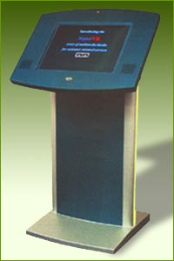
The kiosk can also test for blood pressure, body fat, antioxidant levels and other personal information for medical analysis. The kiosk will have a telephone that can be used as a pay phone or for contacting a service representative from Healing from the Heart. A digital video camera mounted on the kiosk will interact with an Organization representative who will be viewed on the screen in real-time with an on-line connection.

Healing from the Heart will operate throughout the year.

- Pearl Clinic
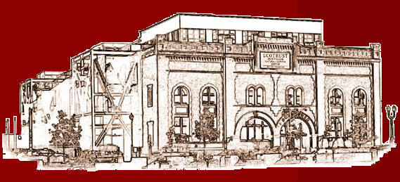

The Pearl Clinic, an innovative, integrated approach to total wellness, ushers healthcare into a new era with Education, Empowerment, and Transformation. Imagine medical professionals who utilize the best of conventional and complimentary medicine to optimize your body’s innate healing response. Imagine all your healthcare options at your fingertips. Imagine a place where your physical, emotional and spiritual health is of the utmost importance.

3. Capital Equipment

Healing from the Heart will require capital equipment for the new facility, transportation vehicles, new equipment, and construction of the new Healing Hearts Center in Post Falls, Idaho. Construction costs are reduced with the purchase of The Pearl Clinic because there are rooms constructed and waiting to be furnished by the purchaser. Capital equipment, modified construction and required supplies are estimated to cost approximately $1,835,000 dollars.

4. Availability of Labor

Rock Pointe Tower is in Spokane County, Washington, the county had an estimated population of 195,629 in 2007. Out of the total population, 101,362 are women which are 51.8% of the adults in Spokane who makes the healthcare decisions for their families in general. Rock Pointe Tower is in the Spokane Metropolitan area, which is one of the State’s major cities and commerce centers. As a result, the Organization does not anticipate any difficulty in hiring employees from the pool of 4.5% of unemployed people in Washington State.
http://www.ofm.wa.gov/trends/tables/fig105.asp

MARKET ANALYSIS
1. Marketing and Sales Strategy

The primary objective of this sales and marketing plan is to support the overall objectives of this business plan in terms of:

- Increasing revenue through the offering of services
- Raising awareness in the market about the services

Pricing is based on commissions and markup, membership, and hourly rate depending on the type of products and services purchased.

Patient care services will be charged at an hourly rate of $75.00. The Organization will take a 25% commission out of the sales of professional services that are located on the Organization’s premises. Training classes for Healing Touch Therapy will cost $22.50 per student.

Sales of equipment such as the Galvanic Spa System and the Evolution Vibration Therapy machine will give the Organization a commission for each unit sold.

Healing from the Heart will take an integrated approach to Marketing Communications (MarCom), believing that any and all means of communicating with the market should be used in a consistent, efficient manner to communicate the benefits the Organization offers.

The Organization will utilize print advertising, Internet advertising, directory listings, and referrals to help promote the business within the target market area.

2. Management and Ownership

Healing from the Heart is a 501(c)(3) non-profit Organization established by Ms. Becky Lee Osterback. The Organization has formed an Executive Committee that consists of the following personnel:

Becky Lee Osterback will serve as the President of the Organization. Her primary responsibilities include developing and executing the sales and marketing strategies to grow the business. She is in charge of strategic planning and the implementation of this business plan.

John Lynn, as the Chief Executive Officer, currently managing over 40,000 and developed a Wellness Program at CA State in Fullerton www.Fullerton.Edu

Chris Meletis, ND, Medical Director, will oversee medical treatment modalities.

Rich Silverman, R.Ph., Director of Pharmacy, (Previous Owner/Developer of Pearl Clinic): will manage all operations within the Health and Wellness Center.

Robert Bartz, Operations Advisor (Rebuilt War-ravaged Kuwait/Managing thousands of people including entire air bases/Security, etc.) Author of Design & Construction of Alternative Power Facilities Project Management with Contract Package Concept & Nuclear Energy: McGraw-Hill Publishing

Rebecca Parker, Family Nurse Practitioner: will direct the efforts of all research and development activities for new products and patient care.

Len Bradford (Developed Boeing’s Spokane Branch) will lead the Human Resources team.

Le Anne Kemmish will serve as the Executive Administrator.

All corporate officers will receive awards for performance by the Chairman of the Board.

3. Personal Experience

Becky Lee Osterback earned her B.S. degree in Nursing in 1980 and is licensed to practice in Washington and Idaho. With over 20 years experience as a Critical Care Nurse, Becky Lee is passionate about the healing process and is continually seeking ways to improve the Organization’s approach to the process. Through the Healing Touch International training program, Ms. Osterback discovered an avenue that has proved to be personally and professionally rewarding. Currently a Healing Touch Clinician, she is in the process of earning her Healing Touch Certification, which is recognized by the American Holistic Nurses Association (AHNA).

Other achievements by Ms. Osterback include successes in real estate and insurance. She is a former owner/trainer of an Anthony Robbins & Associates franchise.

4. Outside Support Team

The Organization will form an outside support team consisting of the following professionals to provide counsel and advice to the management team.

- Accountant: Wes Delaney
- Attorney: To be determined
- Insurance: To be determined

5. Earnings and Projected Success

Based on the services provided by The Pearl Clinic and those provided by Healing from the Heart the President expects sales to earn $2,589,600 the first year, $5,685,600 in the second year, and $8,968,800 in the third year. The net operating income for the first year is projected to be approximately $112,605; $102,507 for the second year; and $334,255 for the third year.

The Organization’s first-year break-even sales revenue is projected to be $2,762,800.

MARKETING AND SALES STRATEGY
The following graphics provide additional insight into the demographic characteristics of the individuals residing within the Spokane, WA Metropolitan Statistical Area:

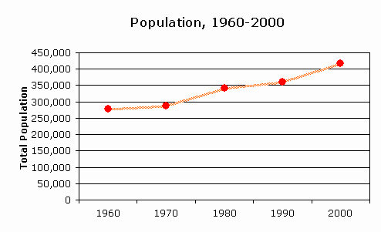 | 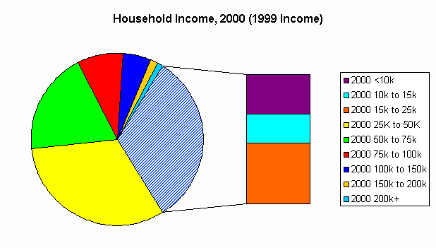
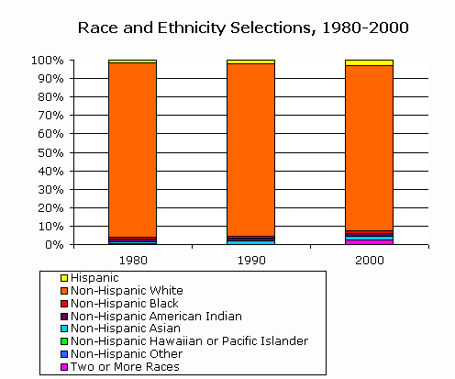 | 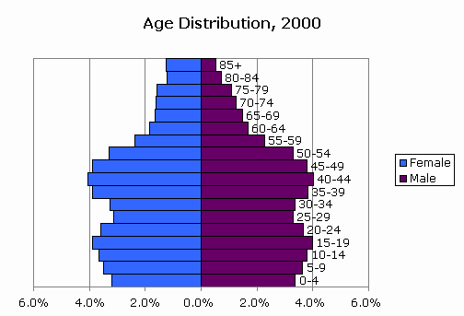

1. What is Healing Touch?



Founded in 1980, Healing Touch International™, Inc. has been instructing Healing Touch practitioners around the world in energy-based care. The training is recognized by the American Holistic Nurses Association (AHNA) as a certificate program and is currently the certifying organization.

Healing Touch is energy-based therapy techniques that encompasses a group of non-invasive movements that utilize the hands to clear, energize, and balance the human and environmental energy fields.

All healing is basically self-healing. A physician can set two bone fragments in place, but the body itself finally heals the split; the physician simply directs and facilitates the process. Healing Touch is a different and often complementary mode of facilitating the healing process, but functions from an energy perspective rather than only a physical one. The Healing Touch Practitioner re-aligns the energy flow, re-activating the mind/body/soul connection to eliminate blockages to self-healing.

2. Description of Services

Training

Healing Touch Clinicians will work with patients and conduct training classes for doctors, nurses and other health care workers in Healing Touch and quality of life therapies including:
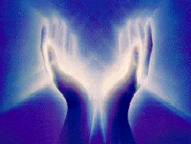
- Pain Management & Diminishment Therapies
- Nervous & Immune System Therapies
- Weight Loss Therapies
- Appearance Enhancement Therapies
- Other Holistic Therapies

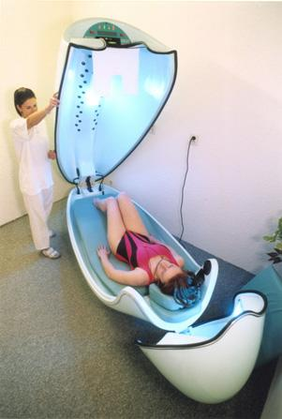
Spa Equipment

Sybaritic spas (e.g. SpectraColor Spa System) will be sold through Healing from the Heart and the business will be an authorized distributor for the equipment. The SpectraColor Spa System provides conditioning and rehabilitation treatment for the whole body. Synergistic sensory stimulation strengthens, rejuvenates, and calms the mind and body for peak performance, harmony and optimum chemical balance. Therapeutically, full spectrum light is used to treat seasonal affective disorder (S.A.D.), eating disorders, jet lag, insomnia, sleep disorders, and premenstrual syndrome (P.M.S).

Merchandise

A variety of products related to holistic medicine and health care will be offered to clients. The product offerings will include oils, vitamins, magnets and other supplies.

Leasing of Professional Office Space

The organization will headquarter in the current offices at W. 316 Boone, Suite 257, with additional space to be acquired as needed, at Rock Pointe Tower Healing Arts Center. The organization will lease office space to professionals for a fee.

Examples of practitioners the business will attract are:

- Massage Therapy | - Acupuncture
- Physical Therapy | - Medical Doctor
- Osteopathy | - Sports Medicine
- Naturopathy | - Healing Touch

Web Site

The Organization’s main source of revenue comes from referrals off the website (www.hwwise.com). Affiliate Agreements are in place to collect fees or commissions from products and services purchased from companies and suppliers on the Internet, when referred from the web site. Clients may log on from their office or home computer, or from a remote kiosk site.
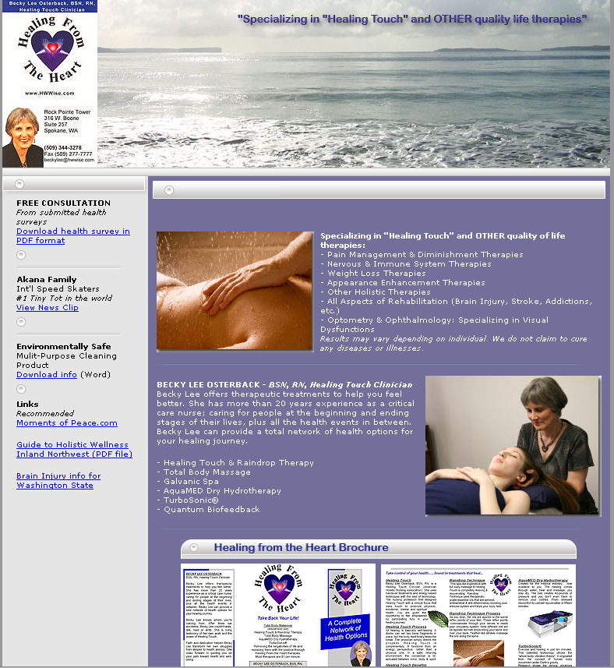

The linked companies and suppliers on the website fall within the mission statement of Healing from the Heart by providing a personal and business referral network for Health, Wealth, and Wisdom.

There are specific web sites contracted with Healing from the Heart for health issues, wealth building, and personalized sites. These web sites provide easy access to information regarding health, business, technology, e-commerce, e-business, consumer protection, purchase comparisons, insurance, airline, automobile and hotel reservations as well as a host of other educational sites.

3. Industry Trends

Healing from the Heart is in the business of health care – sometimes better described as “sickness” care. The business generates revenue through direct patient healing in addition to specialized training and referrals to other health care associates. The foundation of the organization is built on the idea of providing alternative or holistic treatments to patients in need of help.

4. The Foundations of Holistic Health

Holistic Health is actually an approach to life. Rather than focusing on illness or specific parts of the body, this ancient approach to health considers the whole person and how he or she interacts with his or her environment. It emphasizes the connection of mind, body, and spirit. The goal is to achieve maximum well-being, where everything is functioning at the very best levels possible. With Holistic Health people accept responsibility for their own level of well-being, and everyday choices are used to take charge of one's own health.

Ancient healing traditions, dating from as far back as 5,000 years ago in India and China, stressed living a healthy way of life in harmony with nature. Socrates (4th century BC) warned against treating only one part of the body "for the part can never be well unless the whole is well." Although the term holism was introduced by Jan Christiaan Smuts in 1926 as a way of viewing living things as "entities greater than and different from the sum of their parts," it wasn't until the 1970s that holistic became a common adjective in our modern vocabulary.

Holistic concepts fell temporarily out of favor in Western societies during the 20th century. Scientific medical advances had created a dramatic shift in the concept of health. Germs were identified as outside sources causing disease. Gaining health became a process of killing microscopic invaders with synthesized drugs. People believed that they could get away with unhealthy lifestyle choices, and modern medicine would "fix" them as problems developed.

However, for some conditions medical cures have proven more harmful than the disease. In addition, many chronic conditions do not respond to scientific medical treatments. In looking for other options, people are turning back to the holistic approach to health and healing. The Holistic Health lifestyle is regaining popularity each year, as the holistic principles offer practical options to meet the growing desire for enjoying a high level of vitality and well-being.

Holistic Health is based on the law of nature that a whole is made up of interdependent parts. The earth is made up of systems, such as air, land, water, plants and animals. If life is to be sustained, they cannot be separated, for what is happening to one is also felt by all of the other systems. In the same way, an individual is a whole made up of interdependent parts, which are the physical, mental, emotional, and spiritual. When one part is not working at its best, it impacts all of the other parts of that person. Furthermore, this whole person, including all of the parts, is constantly interacting with everything in the surrounding environment. For example, when an individual is anxious about a history exam or a job interview, his or her nervousness may result in a physical reaction--such as a headache or a stomachache. When people suppress anger at a parent or a boss over a long period of time, they often develop a serious illness--such as migraine headaches, emphysema, or even arthritis.

The principles of Holistic Health state that health is more than just not being sick. A common explanation is to view wellness as a continuum along a line. The line represents all possible degrees of health. The far left end of the line represents premature death. On the far right end is the highest possible level of wellness or maximum well-being. The center point of the line represents a lack of apparent disease. This places all levels of illness on the left half of the wellness continuum. The right half shows that even when no illness seems to be present, there is still a lot of room for improvement.

Holistic Health is an ongoing process. As a lifestyle, it includes a personal commitment to be moving toward the right end of the wellness continuum. No matter what their current status of health, people can improve their level of well-being. Even when there are temporary setbacks, movement is always headed toward wellness.

The U.S. Centers for Disease Control and Prevention report that the key factors influencing an individual's state of health have not changed significantly over the past 20 years. Quality of medical care is only 10%. Heredity accounts for 18% and environment is 19%. Everyday lifestyle choices are 53%. The decisions people make about their life and habits are, therefore, by far the largest factor in determining their state of wellness.

The most obvious choice people make each day is what they "consume"--both physically and mentally. The cells in a person's body are constantly being replaced. New cells are built from what is available. Harmful substances or lack of needed building blocks in the body can result in imperfect cells, unable to do what is required to keep that person healthy. Similarly, on the non-physical level, a person's mental attitudes are "built" from what they see and hear.

The majority of illnesses and premature death can be traced back to lifestyle choices. There are the well-known dangers connected with drugs, alcohol, nicotine, and unprotected sexual activity. Less recognized is the impact of excesses in things like sugar, caffeine, and negative attitudes. Combined with deficiencies in exercise, nutritious foods, and self-esteem, these gradually accumulate harmful effects. With time they diminish the quality of the "environment" within that human being, and can set the stage for illness to take hold. Quality of life, now and in the future, is actually being determined by a multitude of seemingly unimportant choices made everyday.

While preventing illness is important, Holistic Health focuses on reaching higher levels of wellness. The right half of the wellness continuum invites people to constantly explore which everyday actions work for them and discovering what is appropriate to move them toward maximum well-being. People are motivated by how good it feels to have lots of energy and enthusiasm for life, knowing that what they are doing that day will allow them to continue to feel this great for years to come.

When disease and chronic conditions do occur, the Holistic Health principles can also be applied. The term is usually changed to holistic medicine, and additional factors are added. The healthcare professionals using the holistic approach work in partnership with their patients. They recommend treatments that support the body's natural healing system and consider the whole person and the whole situation.

A holistic approach to healing goes beyond just eliminating symptoms. For example, taking an aspirin for a headache would be like disconnecting the oil light on the dash of a car when it flashes. The irritation is eliminated, but the real problem still exists. In holistic medicine, a symptom is considered a message that something needs attention. So, the symptom is used as a guide to look below the surface for the root cause. Then what really needs attention can be addressed.

Holistic Health supports reaching higher levels of wellness as well as preventing illness. People enjoy the vitality and well-being that results from their positive lifestyle changes, and are motivated to continue this process throughout their lives.

(The Illustrated Encyclopedia of Body-Mind Disciplines, Suzan Walter, The Rosen Publishing Group, 1999)

What is Holistic Medicine?

Holistic medicine is the art and science of healing that addresses the whole person - body, mind, and spirit. The practice of holistic medicine integrates conventional and alternative therapies to prevent and treat disease, and most importantly, to promote optimal health. This condition of holistic health is defined as the unlimited and unimpeded free flow of life force energy through body, mind, and spirit.

Holistic medicine encompasses all safe and appropriate modalities of diagnosis and treatment. It includes analysis of physical, nutritional, environmental, emotional, and spiritual/lifestyle elements. Holistic medicine focuses upon patient education and participation in the healing process.

Energy Healing

Biofield, or energy healing, is described by its proponents as "one of the oldest forms of healing known to humankind." Theories related to this practice involve transfer of energy from healer to patient in unknown ways, either from a supernatural entity or by manipulating the body's own "energy fields." Over 25 terms are used in various cultures to describe this life force. Biofield practitioners incorporate a holistic focus into therapy, and promote their methods as useful for stress and general improvement of health; relief of pain, edema, and acceleration of wound and fracture healing; improvement in digestion, appetite, and various emotional states; and treatment of conditions such as eating disorders, irritable bowel syndrome, and pre-menstrual syndrome.

Some unique conditions are "diagnosed" by biofield practitioners, such as "accumulated tension" and "congested energy" that, when released, supposedly lead to improved health. A common form of this therapy is used by nurses, and is called "therapeutic touch." It involves moving the hands over (but not in direct contact with) the patient's body either to create a general state of well-being by enhancing "energy flow" in the subject, or to release "accumulated tension" and induce balance and harmony. At least one school of nursing has demanded that its faculty cease teaching these modalities as part of their curriculum (personal communication, John Renner, MD).

Therapies that combine manipulation and biofield therapy include "network chiropractic spinal analysis," which combines soft-tissue chiropractic and applications of the biofield, followed by conventional chiropractic treatment; "craniosacral therapy," an offshoot of osteopathic medicine involving manipulation of cranial and/or sacral bones to relieve "restrictions" in motion of these bones that are thought to help persons with seizures, immune disorders, learning disabilities, and assorted other conditions; and "polarity therapy," in which touch, energy field manipulation, and other modalities correct distortions in one's "energy anatomy."

The holistic medicine industry is growing. Particularly in America, the population is preparing to accommodate the baby boomers as they grow older and their bodies begin to give way to disease and general wear and tear. Throughout the years of the baby boomers (those born between 1946 and 1964), the American economy has dealt with the impact of this massive population bubble. Schools systems swelled to take on the new masses, then closed as the bubble passed. The stock market exploded as baby boomers invested in retirement accounts and we are now seeing those accounts being sold or modified as the boomers begin to retire. The health care industry is now beginning to show signs of stress as the baby boomers age and look for relief in the form of traditional and non-traditional medicines.

5. Healing Touch and the American Medical Association

The American Medical Association recognizes alternative and holistic medical treatment as a form of healing that is growing in popularity. The AMA represents conventional medical wisdom and has published papers on the topic of alternative and holistic medical applications. In a 1997 report entitled “Report 12 of the Council on Scientific Affairs – Alternative Medicine”, the AMA discussed energy-based therapy:

6. Competition/Primary Target Market Location

The relevant Standard Industrial Classification (SIC) code for Healing from the Heart is 8093, Specialty Outpatient Clinics, NEC (“not elsewhere classified”).

Reference USA is an Internet-based reference service from infoUSA – a leading provider of business and consumer information products and database marketing services. The ReferenceUSA database contains detailed information on more than 12 million U.S. businesses.

According to ReferenceUSA’s database there are 3 competing businesses operating within the PMA that fall within relevant Standard Industrial Code (SIC) categories.

Healing from the Heart is a unique service in the immediate market area, and there is little direct competition. The Healing Touch International web site lists the following Washington and Idaho Healing Touch practitioners, instructors, and clinics:

Healing Touch Practitioners

Debbie Kinch, CHTP, LPN
Boise, ID, 208-384-5490

Elly Leduc, RN, CHTP
Olympia, WA, 360-438-1244

Jeanie Scepka, RN, BSN, CHTP
Boise, ID 208-385-9394

Healing Touch Practitioners / Instructors

Sharon L. Fletcher, RNC, CHTP/I
Spokane, WA 509-328-3337

Keela Marshall, RN, ARNP, CHTP/I
Seattle, WA 206-545-7387

Healing Touch Clinics

Boise ID Healing Touch Clinic
St. Alphonsus’ Learning Center
6148 Emerald Street
Boise, ID 208-331-2877

The Healing Touch Clinic of Olympia
Good Shepard Lutheran Church
1601 North Street
Olympia, WA 360-753-2276

Twin Cities (Centralia/Chehalis) Healing Touch Clinic
Rivergreen Healing Arts Center
1570 N. National Avenue, Suite 320
Chehalis, WA

Notably, only one of these Washington and Idaho Healing Touch-related facilities is actually located within the Primary Market Area.

The conventional health care facilities located within the Primary Market Area include:
Holy Family Hospital  5633 N Lidgerwood Street  Spokane, WA 99207  (509) 482-0111  Provident Services Eastern WA  5633 N Lidgerwood Street  Spokane, WA 99207  (509) 482-2458  US Veterans Medical Center  4815 N Assembly St  Spokane, WA 99205  (509) 328-4521  Veterans Administration  4815 N Assembly Street  Spokane, WA 99205  (509) 328-4521  Blair House  2718 W Sinto Ave  Spokane, WA 99201  (509) 327-6133  Deaconess Medical Center  800 W 5th Avenue  Spokane, WA 99204  (509) 458-5800  Gates & Beyersdorf  910 W 5th Avenue # 550  Spokane, WA 99204  (509) 458-5800  Shriners Hospital  911 W 5th Ave  Spokane, WA 99204  (509) 455-7844 | Sacred Heart Medical Center  101 W 8th Avenue  Spokane, WA 99204  (509) 455-3131  Valley Hospital & Medical Center  12606 E Mission Avenue  Spokane, WA 99216  (509) 924-6650  Valley Outpatient Surgery Center  1414 N Houk Road # 204  Spokane, WA 99216  (509) 922-0362  North Idaho Immediate Care Clinic  925 E Polston Avenue  Post Falls, ID 83854  (208) 777-9110  Kootenai Medical Center  2003 Lincoln Way  Coeur D Alene, ID 83814  (208) 666-2000  St Luke’s Rehab Institute  711 S Cowley Street  Spokane, WA 99202  (509) 838-4771  Heart Institute of Spokane  122 W 7th Avenue # 210  Spokane, WA 99204  (509) 625-3000

Conventional Medical Centers in Primary Market Area
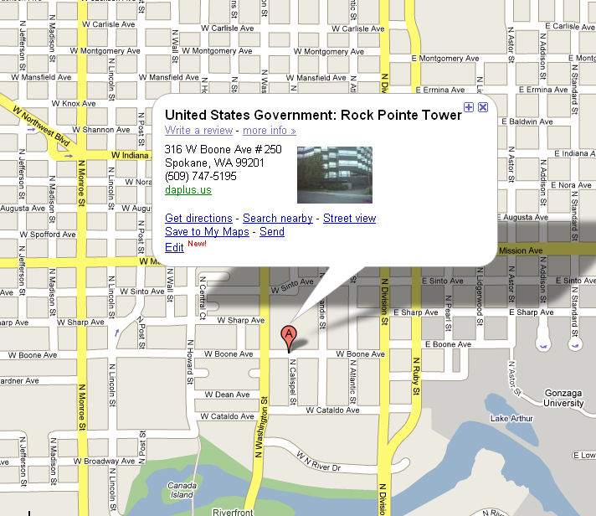
Pearl Clinic in Portland
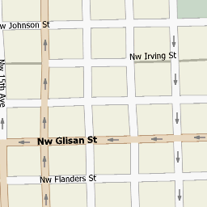

Healing from the Heart has a unique product offered and operates in an area with no or very little direct competition. Unfortunately, there will always be a steady demand for medical treatment from people who are unable to obtain satisfactory relief through conventional medical practices. The Organization will take advantage of this business opportunity while providing a valuable service to the market.

The demand for medical care (conventional and otherwise) will continue to rise as the baby boomer population continues to age. Holistic medicine and healing practices will succeed by responding to this need. Healing from the Heart is therefore in an excellent position to succeed in this industry.

8. Facilities & Operations

The Healing from the Heart facility in Rock Pointe Tower has a service potential of over 4,000 occupants of the Rock Pointe Corporate Center.

Administrative Office – Rock Pointe Tower
W. 316 Boone, Suite 257, 268, and 270.



Healing from the Heart
Personalized Health and Wellness Resource Center and Network

The primary requirements for the location are:
- Convenient location
- Adequate space for operations
- Accessible and comfortable office space

Kiosks will be placed at every airport nationwide as well in every Healing from the Heart Center to establish and give market support to the national distribution of Healing from the Heart Centers. Ms. Osterback intends to manage all business affairs of Healing from the Heart out of the office located at Rock Pointe Corporate Center in Spokane, Washington.

The nationwide placement of the airport kiosks will provide an income source to build additional Healing from the Heart Centers wherever the expanded population creates a need for such a center.

Facility
The main business will continue to be managed out of an office at Rock Pointe Tower, located at W. 316 Boone, Spokane, Washington. This property provides adequate space for the business office as well as suites that offer additional treatment for occupants of Rock Pointe Corporate Center as well as the surrounding vicinity.

The new, expanded office to be built will have facilities for Internet Website Network Management with space to integrate new updated equipment, yet the actual increase in support and network management will be needed to be met with the appropriate support additions.

The Organization intends to extend the impact of its Internet network – now at the grassroots level – by deploying interactive kiosks in approximately 11 cities in the first year, in 24 by the second year, and in 32 kiosk locations by the third year.


All proper utilities and sanitation services are already available at the site. The facility will be handicapped-accessible, and will conform to State and Federal Regulations. In addition, the facility will conform to all local and state codes and ordinances.

9. Sources of Supply

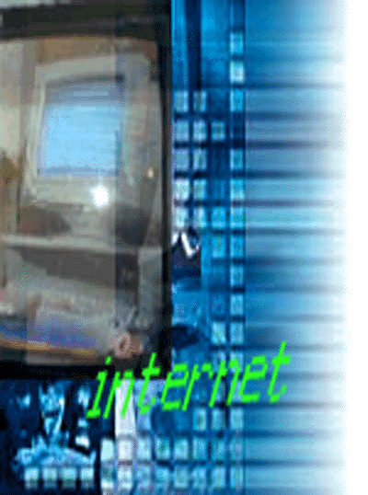





Capital Equipment & Supplies

Healing from the Heart will require capital for the new facility, and for the new equipment. Capital facilities, equipment, and supplies are estimated to amount to approximately $3.3 million dollars.

Capital Expenses
Item Description | Estimated Amount
Property Acquisition and Building | $3,000,000.00
Pearl Clinic Purchase | 500,000.00
Computers / Software / Kiosks | 490,000.00
Furniture, Desks, training Tables, Filing Storage | 200,000.00
Telephone System | 95,000.00
Equipment and Products | 250,000.00
Miscellaneous Expenditures | 300,000.00
Total | $ 4,825,000.00

The Organization intends to increase business operations using adequate and reliable equipment so as to maximize customer service and efficiently manage the profitability of the company. In order to meet the intentions of this proposed business plan, the new equipment will be needed.

Computer Systems
The Organization will use computer hardware and software to improve its effectiveness and efficiency in a number of functions including:

- referencing for contacts and contracts
- inventory and supplies management
- payroll analysis and processing
- bookkeeping
- Internet contact and support

Sales Information Systems
To track and control inquiries and other contacts relevant to the referral and customer-base growth and database maintenance, the Organization will use computer hardware and software that will permit it to:

- record information about contacts
- research calls information and location
- qualify inquiries

The supply of property construction and maintenance, and related businesses and other services are plentiful in Spokane, Post Falls, and the surrounding areas. There are many sources, both local and from original equipment manufacturers (OEM), for the vehicles and equipment that the business needs to acquire.

The business’ primary supply sources are:
- Professional Resource Systems International
- World Marketing Alliance
- Electric Lightwave
- Elo Touch (Kiosks)
- Healing Arts Center
- Cisco Systems
- Citx

Tools and other equipment also are available from other sources such as tool distributors and retailers in addition to many national catalog wholesalers. Supplies for the administrative functions of the business such as computers, office equipment and supplies are readily available from many sources in the area, thus making it possible for the business to obtain all of its necessary office equipment and supplies at competitive prices.

10. Objectives


The primary objective of this sales and marketing plan is to support the overall business objectives of this business plan – namely to:

- Increase revenue through the offering of a new service
- Raise awareness in the market about the service

An analysis of our current situation reveals that we face little competition in our target market. This plan focuses on the implementation of marketing strategies designed to maximize our performance in the target market given our current position and the available marketing resources. Our primary strategy is to increase awareness about the availability of a new healing and wellness center in Spokane. We will pursue this strategy by utilizing informed marketing projections.

Marketing Objectives

Our marketing plan is designed to accomplish the following objectives:

- Raise awareness about the need for a healing center such as ours

- Inform potential customers about the services we offer

These objectives drive the rest of our plan, determining our approach to marketing and sales. This plan is designed to move us forward on all these objectives.

The rest of this plan details our marketing situation and why it requires these objectives, and the strategies and tactics we will use to accomplish the objectives.

Our Most Important Objective

Marketing programs generally have many components, and they often pursue multiple objectives as well. Ours is no exception. In the beginning of this section, we identified a number of objectives that we feel are important to our future growth and profitability. However, by prioritizing these objectives, we are able to focus our plan better than most marketers do. We will be able to get more return on our marketing investment as a result of this greater focus.

Our analysis of the situation indicates that one particular objective is more important than the others. It is to inform potential customers about the range services we offer. Our plan emphasizes the pursuit of this objective over all others, and we intend to track our performance against it carefully during the coming year.

11. Current Marketing Situation

Our analysis of the marketing situation indicates that we are in a fast-growing market. We define our current target market as adults seeking alternative medical treatment. This plan targets current and potential patients who reside in the immediate market area of Spokane/Coeur d’Alene as well as the national market by means of e-commerce.

12. Positioning Statement

All Healing from the Heart advertising executions will include one or more positioning statements designed to support the impression of an alternative, holistic healing and training center. Our positioning statement is:

“Take Your Life Back!”

13. Pricing Strategy

Pricing for products and services is based on commissions and mark-up, depending on the service purchased. Patient care services will be charged at an hourly rate of $60/hr. Professional services located in the company’s building will be charged a commission rate of 25% of their fees. Training classes for Healing Touch therapy result in a fixed fee of $22.50 per student, charged to Healing Touch International. Sale of equipment such as the SpectraColor Spa System that treats light deficient ailments will earn a commission of nearly $1,000 for each unit sold.

14. Marketing Communications

We take an integrated approach to Marketing Communications (Mar Com), believing that any and all means of communicating with our market should be used in a consistent, efficient manner to communicate the benefits of our offerings. The following section describes our advertising, sales and other communication channels and provides an integrated plan and budget for all MarCom activities over the coming year.

Printed Advertising
Many patients will notice our sales literature posted in popular areas frequented by our target market. We will post literature in natural markets and other health conscious grocery stores.

Internet Plan
The main source of revenue comes from referrals on the Healing from the Heart website. Affiliate agreements are in place to collect fees or commissions from products or services purchased from companies and suppliers on the Internet, when referred from the Healing from the Heart web site: www.HWWise.com. Clients can either log-on from their office or home computer, or from a remote kiosk site.

These companies and suppliers fall within the Healing from the Heart mission of providing a personal and business referral network for Health, Wealth, and Wisdom.

There are specific web sites contracted with Healing from the Heart for health issues, wealth building, and personalized sites for easy access to information regarding health, business, technology, E-Commerce, E-Business, consumer protection, purchase comparisons, insurance, airline and automobile reservations, hotel reservations, and a host of other educational subject areas.

We may use a web page in the future to attract interested web users, and to give them easy ways of obtaining information about our offerings. Our web site will capture information about potential customers, providing a stream of sales leads for follow-up.

Directories
Our customers often initiate purchases by searching for suppliers like us in directories. Specifically, customers use their local Yellow Pages telephone directory. Given customer usage patterns, we may purchase ads and listings in the Spokane, Washington and Coeur d’Alene, Idaho Yellow Pages.

MANAGEMENT
1. Plan Organization and Implementation

When possible, the execution of this marketing plan will be coordinated by Becky Lee Osterback. Organizational support by outside suppliers includes:

- Marketing and/or Public Relations Consultant
- Graphic Design
- Printer

2. Organizational Map

Healing from the Heart is a non-profit Organization incorporated in the state of Washington, and established by Ms. Becky Lee Osterback. The Organization has received recognition from the Internal Revenue Service of its status as a 501(c)(3)-qualifying non-profit entity. As a non-profit entity, the Organization has no owners per se. Rather, the Organization’s corporate charter indicates the manner in which its assets should be distributed to other non-profit organizations should Healing from the Heart cease to continue as an ongoing enterprise.

Becky Lee Osterback
President
Medical Director:
Dr. Chris Meletis
Portland

Dr. Karen Stenek
Spokane
Rich Silverman
Health & Wellness
Center Development
Janis Steading
Grant Writer
John Lynn
Chief Executive Officer
Care Division:
Rebecca Parker
Portland

Fran Collins
Spokane
Le Anne Kemmish
Executive Administrator
Len Bradford
Human Resources
Robert Bartz
Operations Advisor

3. Statement of Purpose

Healing from the Heart will build a competent, enterprising and responsible organization in which each individual has an opportunity to contribute and benefit. We will promote a feeling of security and self-confidence that will enable co-workers to think and act creatively and effectively in performance of their specific discipline, thus achieving the fullest possible measure of success, health and happiness.

We believe our reasons for being are more than economic. We have assumed moral and social responsibility as a matter of conscience. The achievement of this responsibility is dependent on growth and profits. If we as an organization do not profit, there will be no means of fulfilling our vision.

4. Corporate Values

Our Organization will:
- Operate its business in a manner that will provide increasing benefits both in the short term and long term to shareholders, co-workers, suppliers, and clients. We will endeavor to satisfy these diverse interests through growth in sales, profits, and benefits and at the same time achieve and maintain financial integrity.

- Function in a manner that will preserve the dignity and well being of its employees and their families. We will constantly strive to provide opportunities for performance, recognition, advancement, individual creativity, and a climate and spirit conducive to clear open communications, participative management and teamwork.

- Rapidly grow sales while maintaining a reasonable profit. Employees are motivated to control costs and increase production. New customers will be evaluated for their long-term effect on our growth and profitability. The policy to pay wages and benefits equal to comparable positions in the industry shall be maintained.

- Build an outstanding corporate image, a people-oriented management style, and a stress on quality in our products.

- Produce and promote programs, internal and external, that are sensitive to the environment, conservation, equal opportunity and access, employee relations and consumer protection.

- Carry on a tradition of being a good corporate citizen by engaging in civic and philanthropic projects in order to enhance the environment and lifestyles of the people we touch.

- Make our community in which we do business better to live and work in as a result of our presence.

We stand for something.

We know who we are.

We have pride in what we are doing.

And we have a sense of community about doing it.
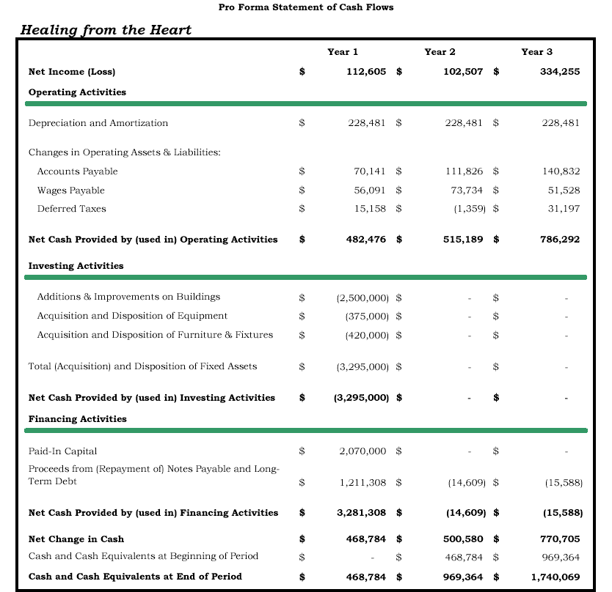

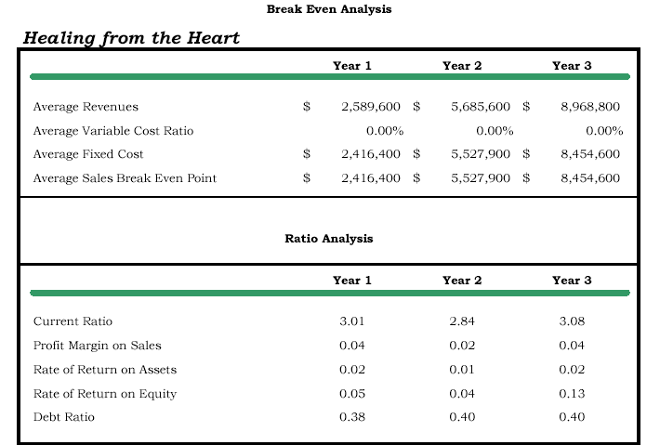

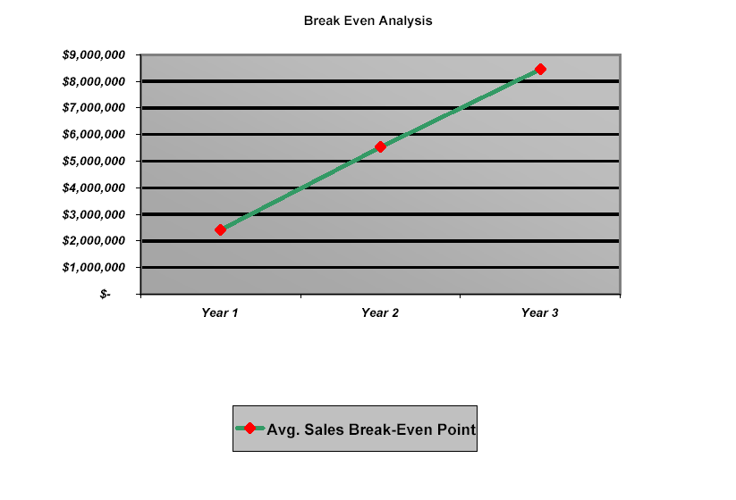
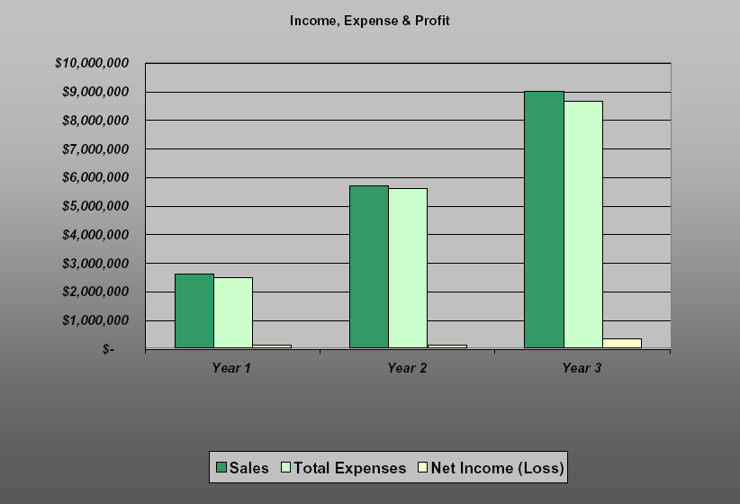

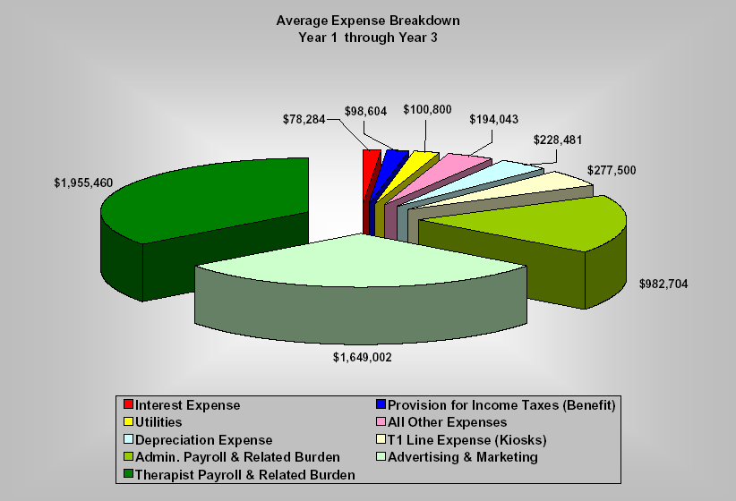
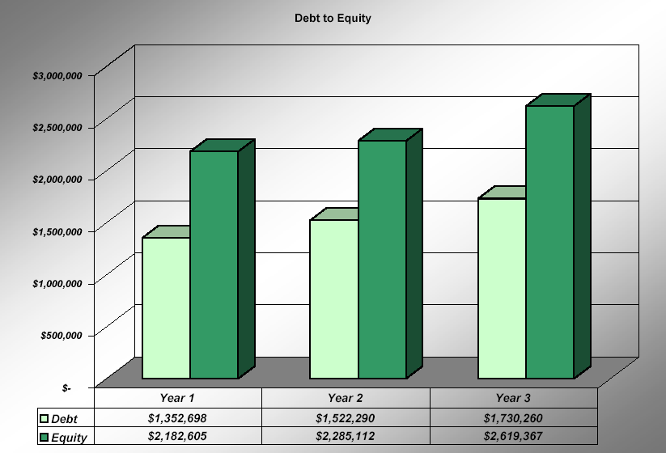

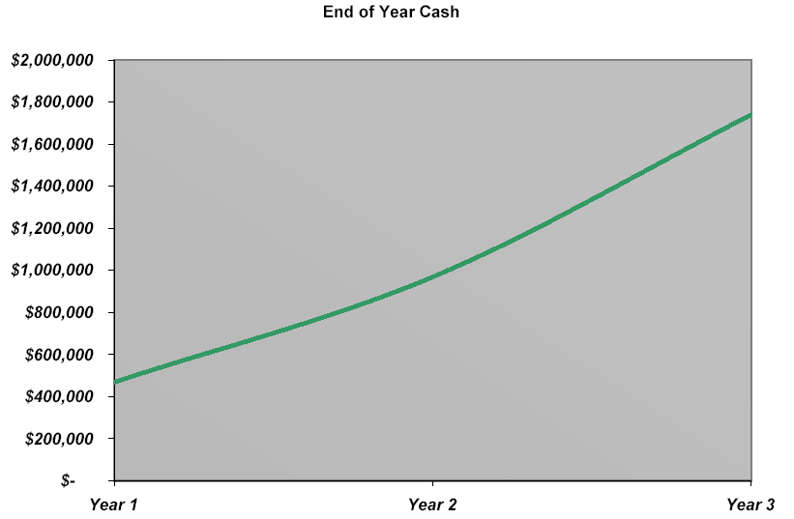
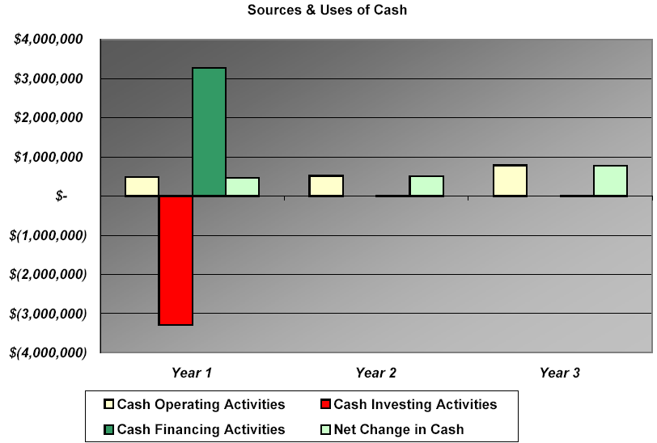
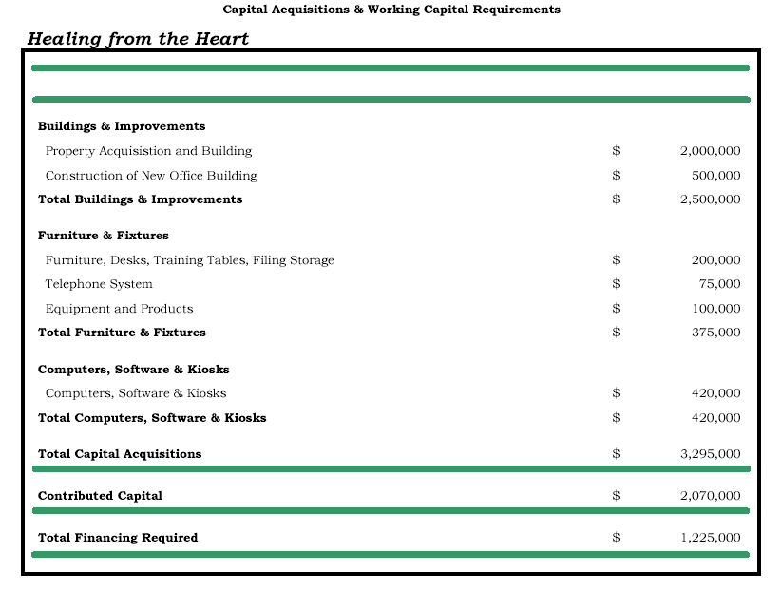

Healing Touch International™
American Holistic Medical Association
Brennan B, Rosner A, Demmerle A, et al. Manual healing methods. In: Alternative Medicine: Expanding Medical Horizons. Washington, DC: US Government Printing Office; 1994. NIH 94-066.
Brennan B, Rosner R, et al. Manual healing methods. In: Alternative Medicine: Expanding Medical Horizons. Washington, DC: US Government Printing Office; 1994. NIH 94-066.

